The Great Gatsby – Literary Analysis Project
DUE Wednesday, January 13
Objective: CCSS 10.RL.3 – Analyze how complex characters develop over the course of the text.
Objective: CCSS 10.W.4 – Produce clear and coherent writing in which the style is appropriate to the task.
While writing formal literary essays is a great way to show understanding and practice academic English, they aren’t the only way to show comprehension. So, as a culminating project for The Great Gatsby, you’ll be asked to select a project from the list below and complete it by January 13th.
NO LATE PROJECTS WILL BE ACCEPTED.
Essays and Singles profiles (1 &2 must be turned in) on the classroom.google.com assignment.
THE PROJECT:
Each project must be neat and organized. Effort must be visible. The grade is based on creativity, neatness, accuracy, and effort. Choose a project that appeals to your own personal talents and interests. (There is a big difference between something you jot down in a few minutes and something you put time into). An assessment rubric is listed on the back.
1. GOOD OL’ ESSAY!  For those of you who want further help developing your analytical writing skills. Feel free to try and branch out from the standard five paragraph essay, but be sure to develop and support your ideas.  PROMPT:  Make a stance on whether Gatsby is “great” or not? What might Fitzgerald’s point be to create this classic novel about a character of questionable background achieving great things… albeit through not great means?  Things you might want to discuss, but make sure you examine one idea FULLY, don’t try to answer all of these:  - Gatsby’s “resolutions”  - His undying love for Daisy  - His resourceful ness  - His parties and “giving” nature  - His “hope,” as Nick puts it.  Write a two-page essay examining the following prompt. Must use examples from the text and at least two in-text citations. | 2. I JUST NEED A DATE  By the end of the novel it’s a toss-up about what characters are likable, much less dateable or even marriage material. So, to show that you have tried to understand the characters (and to help them get a date) you are to create online singles profile for the following:  - Tom Buchannan  - Daisy Buchannan  - Jay Gatsby  - Nick Carraway  Must use at least one quote from that character in your profile.  Use the example on the back of this paper about Jordan Baker to model your other profiles on. Be creative. Be thorough. Be accurate to the story. But most of all, be funny. It’s been a grand semester so end it with a laugh for Mr. Restad. | 3. IMAGE IS EVERYTHING  Create a cover page of a gossip magazine similar to the one at Myrtle and Tom’s apartment in the city, Town Tattler. Think about the gossip magazines you see at the grocery store. Include at least five pieces of gossip about characters, for example, the rumors about Gatsby killing a man and/or being a bootlegger, his affair with Daisy, his “wild” parties, etc. The cover of your magazine must be professional (so, if you’re not the world’s best artist, create your magazine cover electronically). Include a minimum of five, colorful visuals.  Hint: Go to Google Images and search for “1920’s Gossip Magazines” or US Weekly to get a better idea of how to create an authentic looking document.

Rubric | 4 | 3 | 2 | 1
Content  (the analysis part) | Clearly addresses the prompt, has strong supporting details that show the meaning and method of your project. | Has a clear thesis and specific supporting details from text. | Contains a thesis, but is inconsistent in focus. Gives support and conclusion. | Does not address the prompt. Project lacks strength or clarity. Missing support or conclusion.
Organization (clean up your room!) | Has a strong introduction with substantial support of claims and citations. Finishes with conclusion. Excellent use of transitions between ideas. | Has a clear intro and conclusion. Shows some logical progression. Uses transitions. | Intro and conclusion is present. Shows some consistency and order in writing or presentation. | Project is all over the place. Hard to follow logic and/or doesn’t back up claims with support. Unable to identify introduction and conclusion.
Presentation | Superior editing. Few errors in grammar, spelling, and citation. Essays are in MLA format. PROOFREAD. Productions are polished. | Careful editing with a few more mistakes in convention. PROOFREAD. | Many spelling and grammatical mistakes. Clearly not proofread or practiced. | Com’on the word processer has a spell check doesn’t it? Let’s give it another try

SAMPLE SINGLES PROFILE:
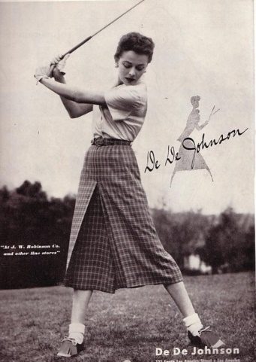
JORDAN BAKER
FAVORITE QUOTE: “I don't give a damn about you now, but it was a new experience for me, and I felt a little dizzy for a while.”
PERSONAL PROFILE: (~150 words)
Well, what they say is true: unlucky at love, great at golf. I just got out of a terrible relationship with a terrible person, Nate Carrington, or something. I forget his name. I guess that would make me a professional golfer seeking… whatever. Preferably a rich, handsome, hulk of a man. If that Daisy biddy ever dumps her husband you can bet this online profile will be down in seconds. I barely can stomach people and can’t STAND parties. Everyone is just so… careless. I guess I’m waiting for my knight in a shining Rolls Royce to show up and sweep me away, shut up, and just do what I want when I want… if I end up wanting to do anything at all.
INTERESTS: (4-5 interests)
Golfing, getting a tan, not drinking, laying about on rich people’s couches, hating on everyone at parties.
TLDR: (Too long didn’t read, sum up your character in one sentence)
In short I’m gorgeous and charming. Shut up and call me. Or don’t. Whatever.

